**An Essential Guide of Data Stream in AK28 for FPV Display in QGC**

1. Data Stream

The Sky Station (Receiver) is connected with the web camera. The first step is to acquire the video stream data in RTP protocol format which is transferred in TCP protocol. Then the second step is to pack RTP data into SIYI SDK package and send it to the Ground Station (Transmitter).

The Ground Station will send the video data into the Android system display through a USB port which is coming with STM32. The USB VID has been changed to 0x0485 and the PID to 0x5742.

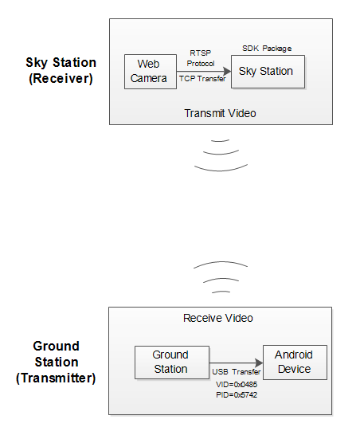

1. Protocol Analysis

Several steps are required to analyze the video data to the original H.264/H.245 data.

1. Analyze the SIYI SDK protocol
2. Analyze the package protocol for transferring RTP data in TCP protocol
3. Analyze the RTP protocol

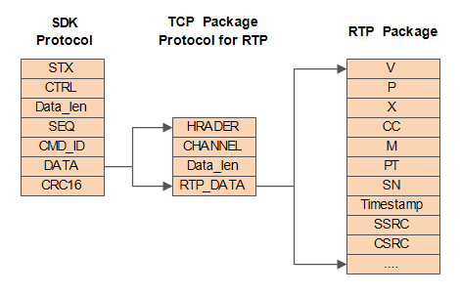

**SIYI SDK Protocol**

|  |  |  |  |
| --- | --- | --- | --- |
| **Field** | **Index** | **Bytes** | **Description** |
| STX | 0 | 2 | “0x5566” is the mark of the beginning of the package |
| CTRL | 2 | 1 | 0:need_ack (if the current data package need “ack”);  1:ack_pack(if the package is an “ack” package)  2-7:resevered |
| Data_len | 3 | 2 | Byte length of the Field  *Low bytes are in front of all |
| SEQ | 5 | 2 | The sequence of a frame (0~65535)  *Low bytes are in front of all |
| CMD_ID | 7 | 1 | Command ID  0x24: the data stream in H.264 format  0x25: the data stream in H.265 format |
| DATA | 8 | Data_len | Video data stream |
| CRC16 |  | 2 | The CRC16 check of the complete data package(including the SDK package head)  *Low bytes are in front of all |

**The TCP Package Protocol for RTP**

|  |  |  |  |
| --- | --- | --- | --- |
| **Field** | **Index** | **Bytes** | **Description** |
| HEADER | 0 | 1 | Package head is fixed to be “0x24” |
| CHANNEL | 1 | 1 | 0x00: RTP data  0x01: RTCP data |
| Data_len | 2 | 2 | Data length  *Low bytes are in front of all |
| DATA | 4 |  | RTP/RTCP data |

**Mark: Due to the limit RAM of the SCM, while it is dealing with long TCP packages, it will pack each piece of the TCP packages separately, so that the packages will be cut into several SDK protocol packages.**

***\*Please feel free to contact SIYI Technology if any part of this guide is not clear enough.***